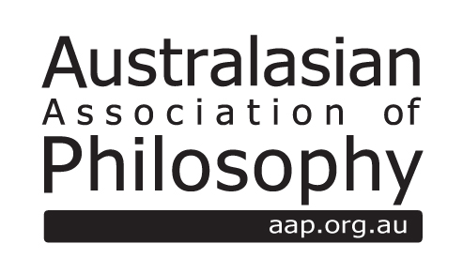

AAP Media Professionals’ Award Nomination Form
http://aap.org.au/AAPmediaproffesionalsaward

Name of Nominee:
Position:
Email Address:

Publication citation details:
Publication URL (if available):

Statement against the judging criteria (no more than 500 words):

Summary of the reach of the piece, e.g. data on the size of audience or other indication of reach and/or impact (no more than 200 words):

If this is a nomination on behalf of someone else:
Name of nominator:
Position:
Email Address:

Please attach a soft copy of the entry to the electronic application. Entries consisting of a lengthy portfolio of items should submit the best one or two and list the remainder.

About the Prize

The Australasian Association of Philosophy offers on occasion a monetary award to media professionals for excellence in the presentation of philosophy or philosophical issues in the media.

Eligibility
The award is open to media professionals including journalists, presenters, producers, editors and others.
Media includes print and online publications, as well as radio broadcasts, television broadcasts and film.
Entries are expected to have gone to air, been published, or occurred in the year (calendar) previous to the prize award, as appropriate for the format of the entry.
The prize would not normally be awarded to the same person more than once.
The media officer, in consultation with the Philosophy in the Community Committee, will make a ruling on any questions relating to eligibility.

Criteria of Evaluation:
- The primary criterion is the ability of the activity, episode or piece to engage the interest of the general public in philosophy or some philosophical issue.
- In addition, the philosophy should be of acceptable quality, sufficient to justify the implicit AAP endorsement of quality conveyed by the prize.
- Consideration should also be given to the size of the audience reached.

